## What is Cloud Computing?

Cloud computing is a term referred to storing and accessing data over the internet. It doesn’t store any data on the hard disk of your personal computer. In cloud computing, you can access data from a remote server.

## What is AWS?

The full form of AWS is Amazon Web Services. It is a platform that offers flexible, reliable, scalable, easy-to-use and, cost-effective cloud computing solutions.

AWS is a comprehensive, easy to use computing platform offered Amazon. The platform is developed with a combination of infrastructure as a service (IaaS), platform as a service (PaaS) and packaged software as a service (SaaS) offerings.

**What is Region and availability Zone?**

Each Region is a separate geographic area. Availability Zones are multiple, isolated locations within each Region .Local Zones provide you the ability to place resources, such as compute and storage, in multiple locations closer to your end users.

## Important AWS Services

Amazon Web Services offers a wide range of different business purpose global cloud-based products. The products include storage, databases, analytics, networking, mobile, development tools, enterprise applications, with a pay-as-you-go pricing model.

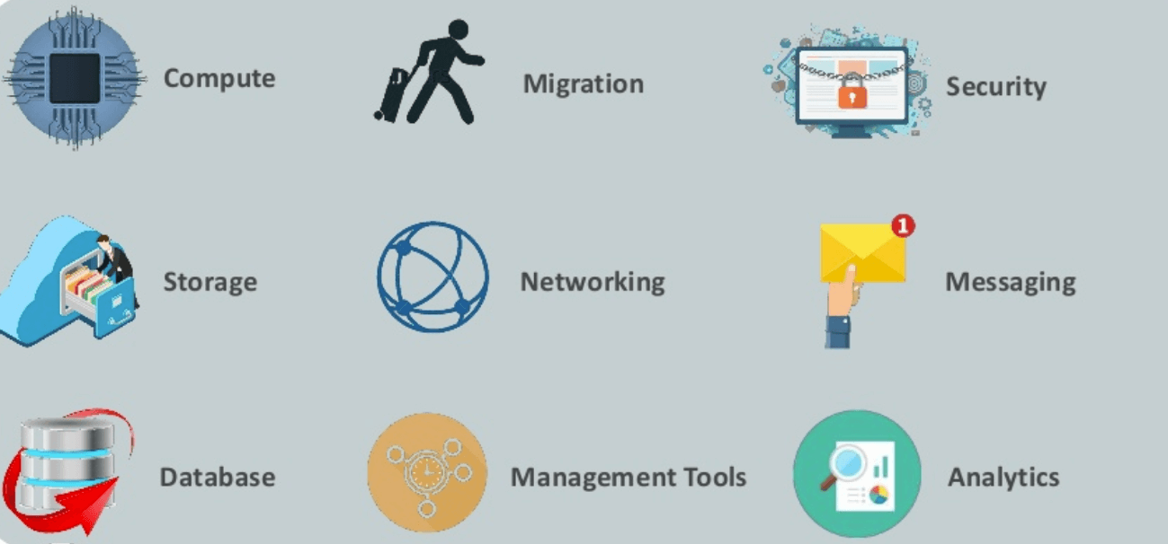

**Vpc**

Amazon Virtual Private Cloud (Amazon VPC) enables you to launch AWS resources into a virtual network that you've defined. This virtual network closely resembles a traditional network that you'd operate in your own data center, with the benefits of using the scalable infrastructure of AWS.

1.First type vpc search

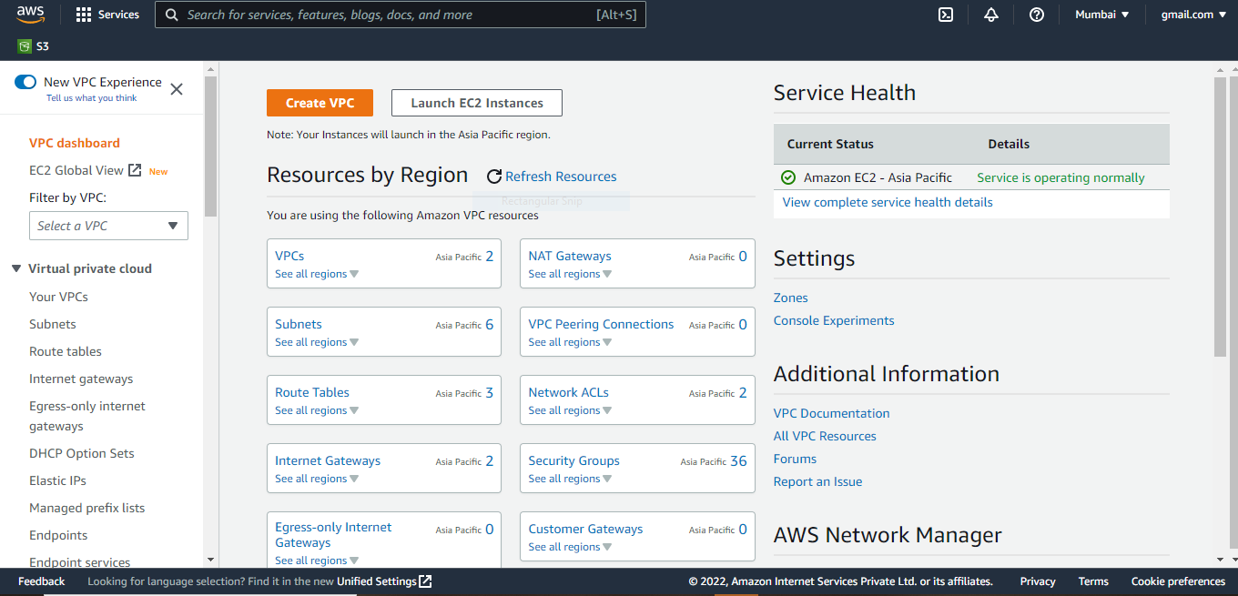

1. click vpc

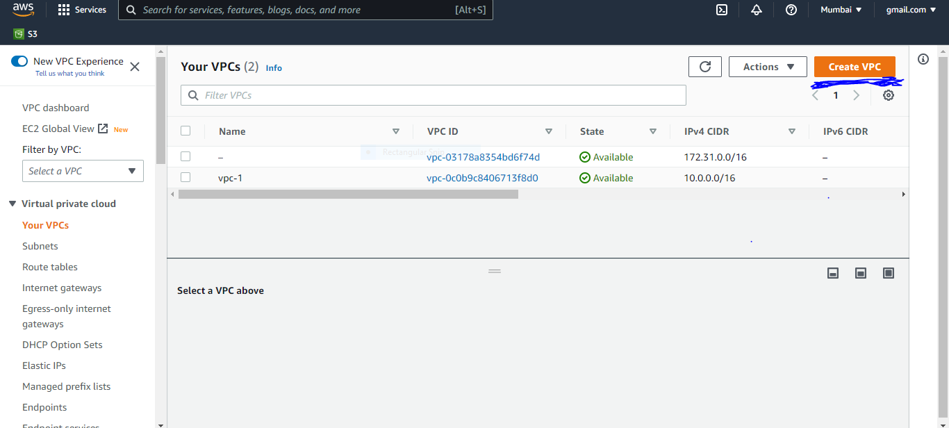

1. Creates a tag with a key of 'Name' and a value that you specify.
2. IPv4 CIDR

[**https://mxtoolbox.com/subnetcalculator.aspx**](https://mxtoolbox.com/subnetcalculator.aspx) **(vpc to subnet calculator link)**

1. **Click create vpc**

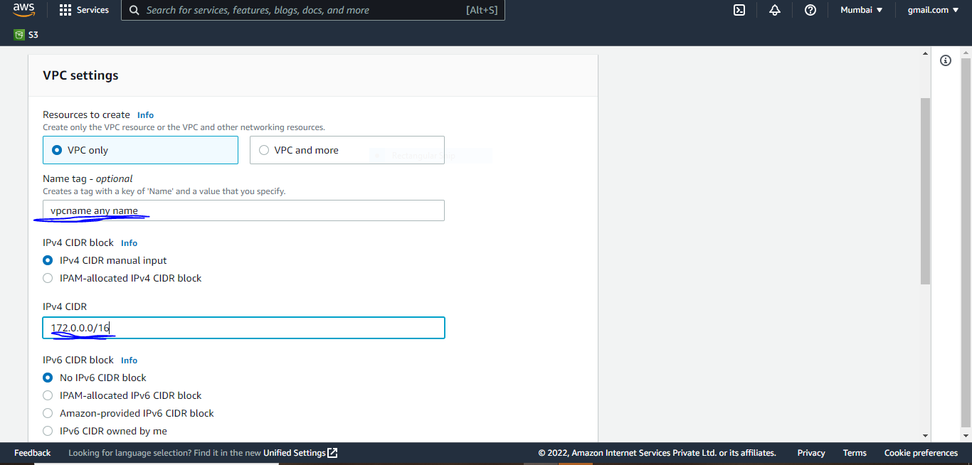

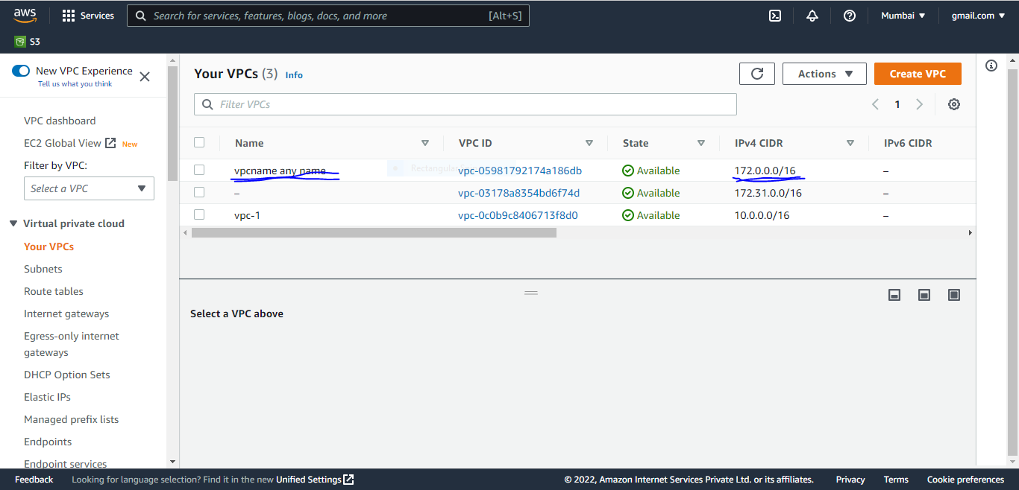

**Subnets**

A subnet is a range of IP addresses in your VPC. After creating a VPC, you can add one or more subnets in each Availability Zone.

subnet, or subnetwork, is a segmented piece of a larger network.

1.Click create subnet

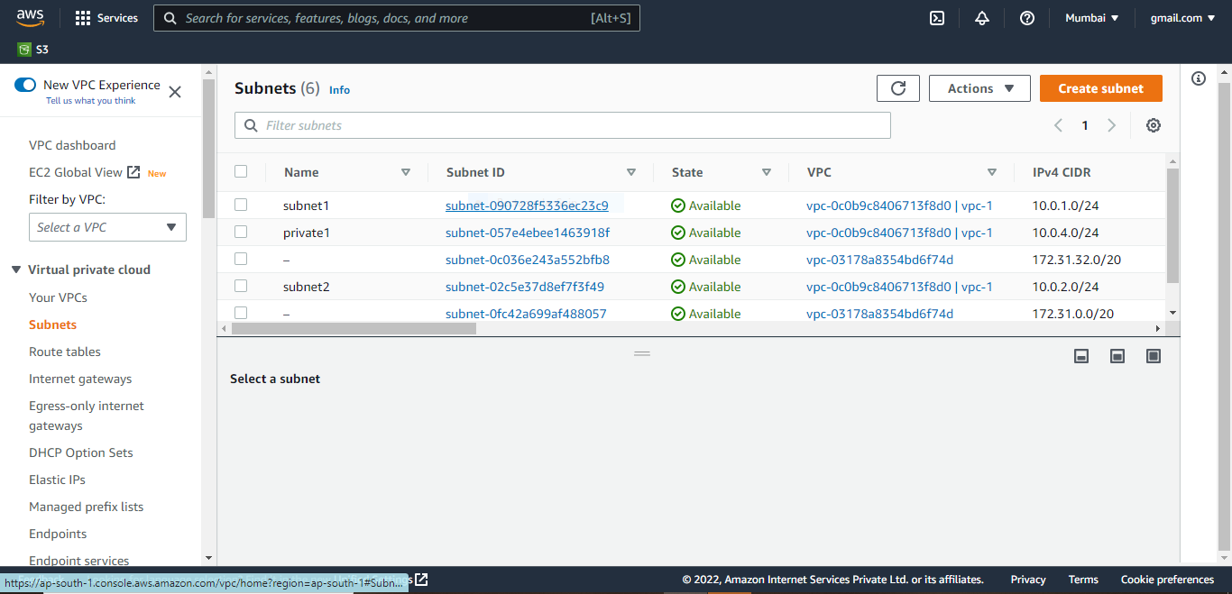

1. Your Vpc Ip
2. Subnet name (any name)
3. Availability Zone (A,B,C)
4. IPv4 CIDR block (10.0.1.0/24) (172.92.1.0/28) (172.0.1.0/24)
5. Click Create subnet

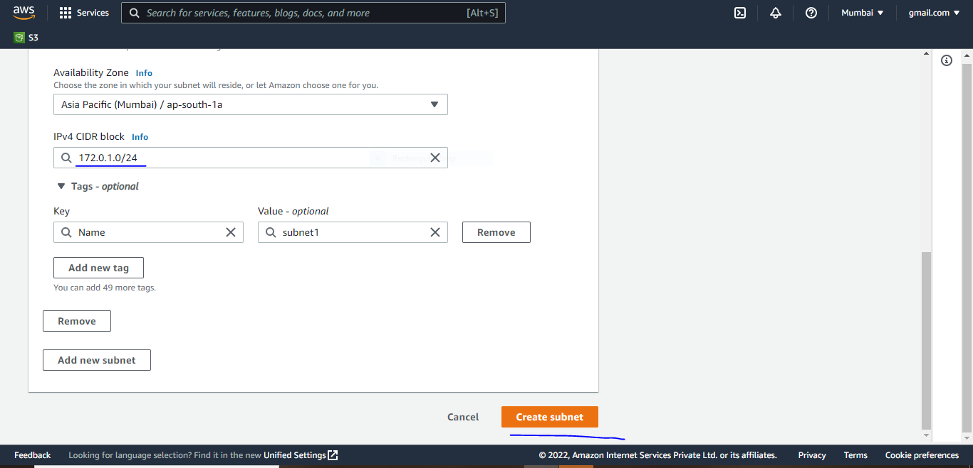

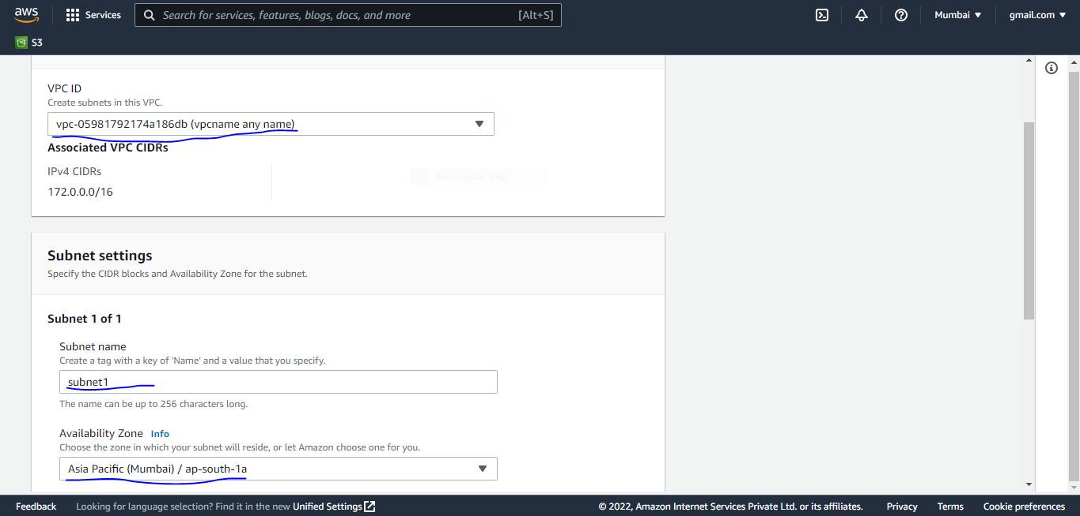

1. Click right button
2. Edit subnet setting
3. Enable auto-assign public IPv4 address click
4. save

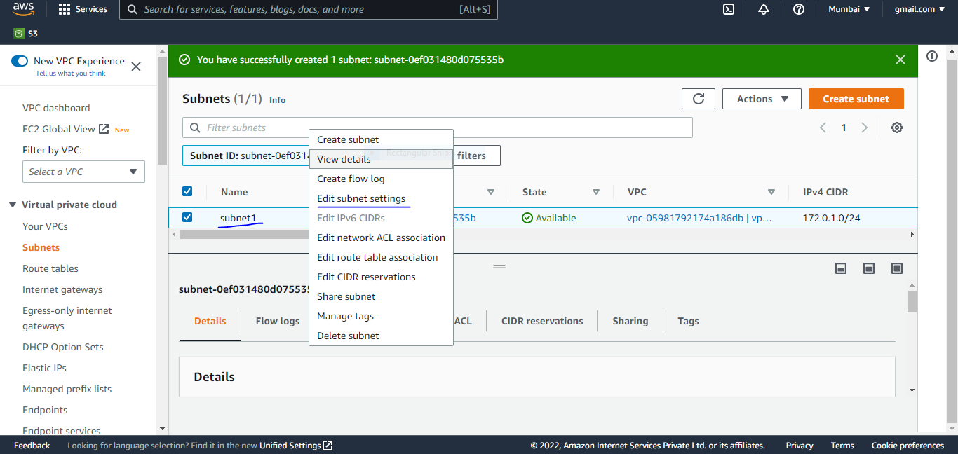

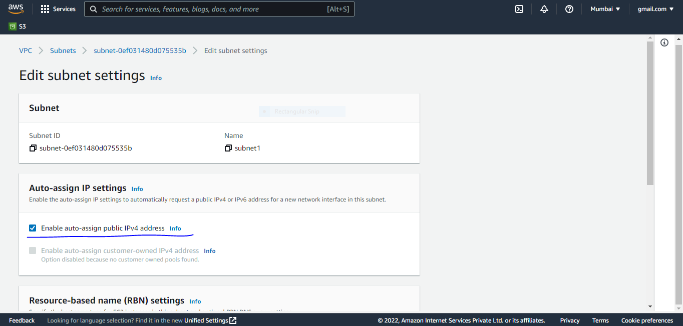

**Internet gateways**

An internet gateway is a horizontally scaled, redundant, and highly available VPC component that enables communication between your VPC and the internet.

To use an internet gateway, attach it to your VPC and specify it as a target in your subnet route table for internet-routable IPv4 or IPv6 traffic.

1. Click create internet gateway
2. Name (any name)
3. Click Create internet gateway

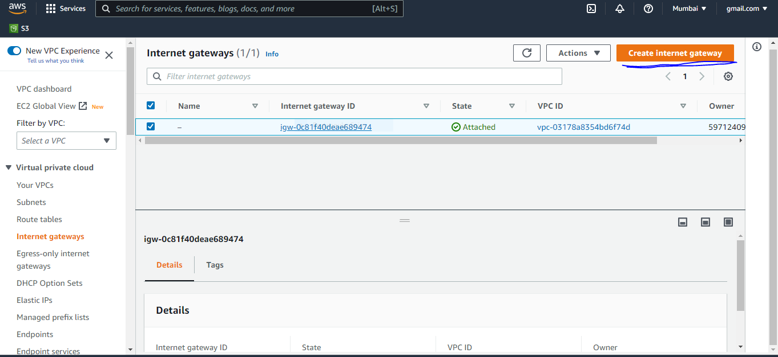

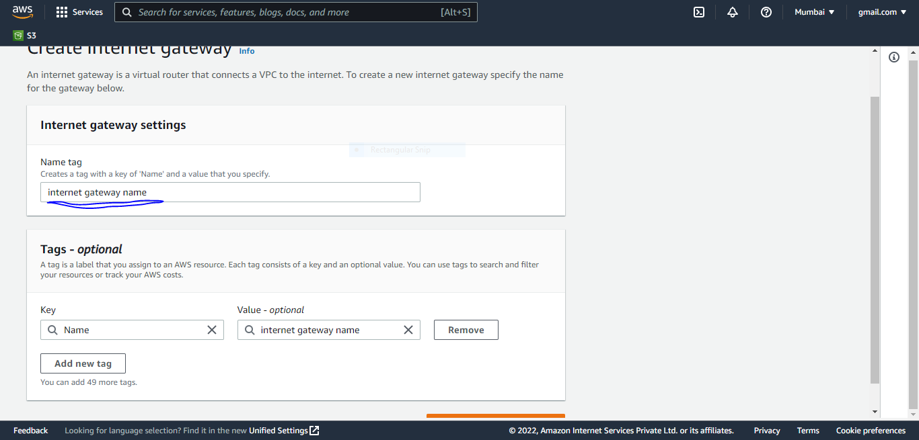

1. click your internet gateway name
2. Attach to vpc

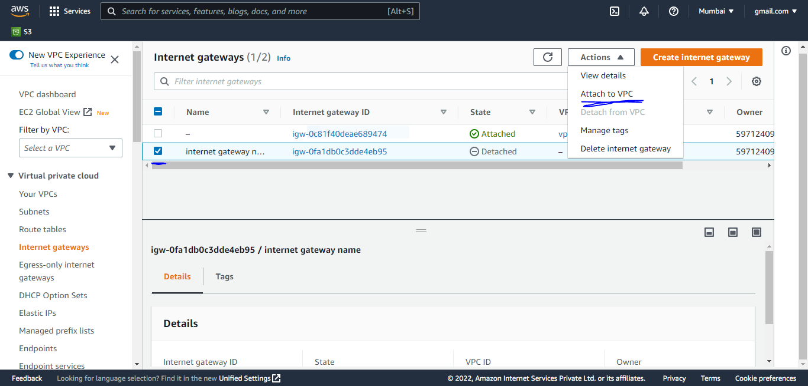

1. option vpc
2. Attach gateway

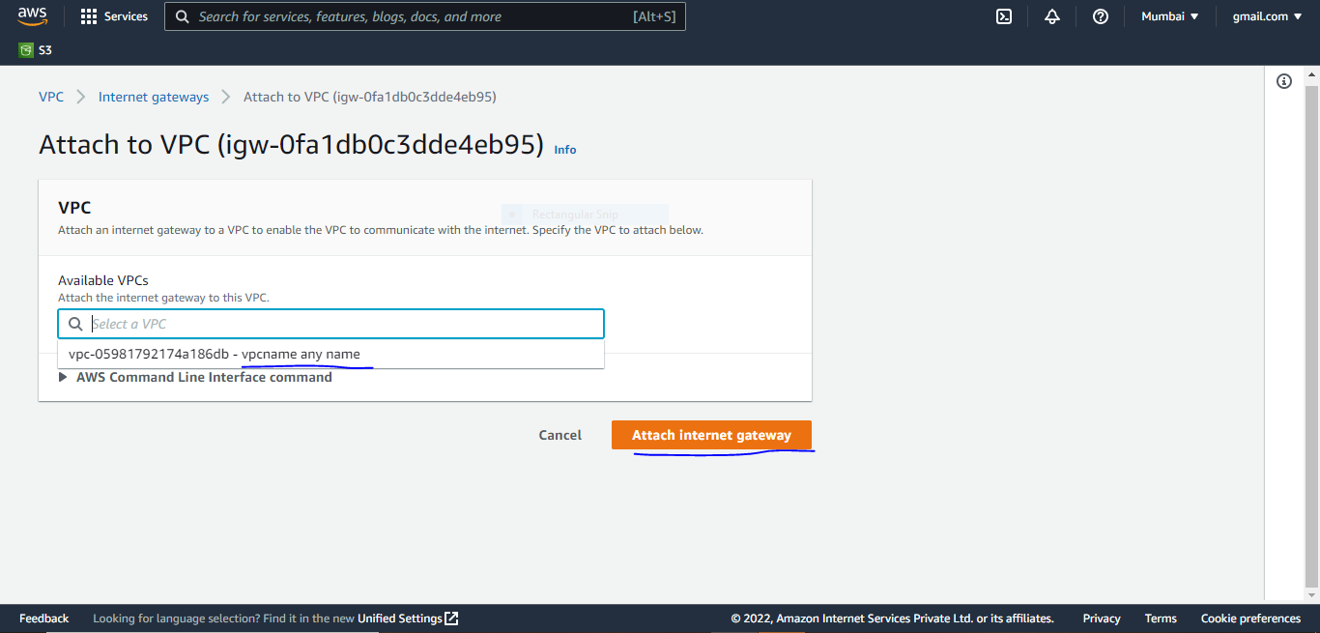

**Route table**

A route table contains a set of rules, called routes, that are used to determine where network traffic from your subnet or gateway is directed.

1. Click create route tables

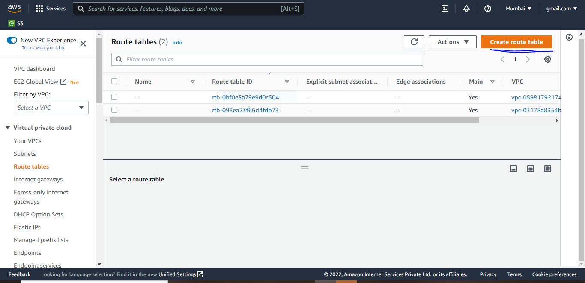

1. Name
2. Your vpc id
3. Create route table

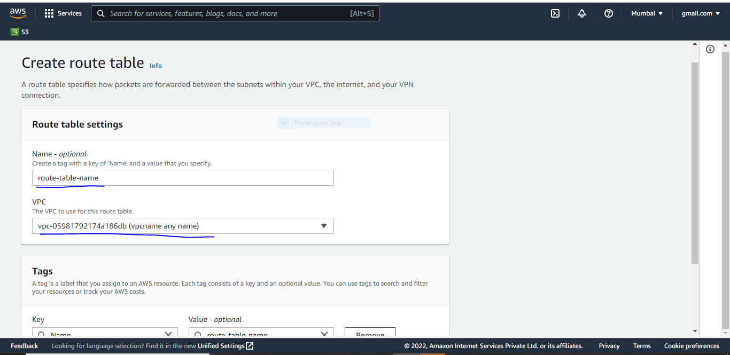

1. Click route table
2. Click subnet associations
3. Edit subnets associations

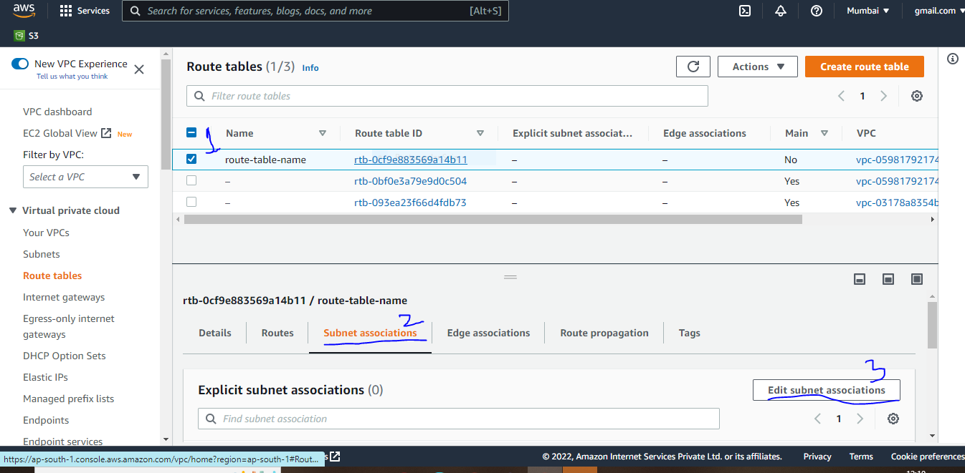

1. click your subnet name
2. Save

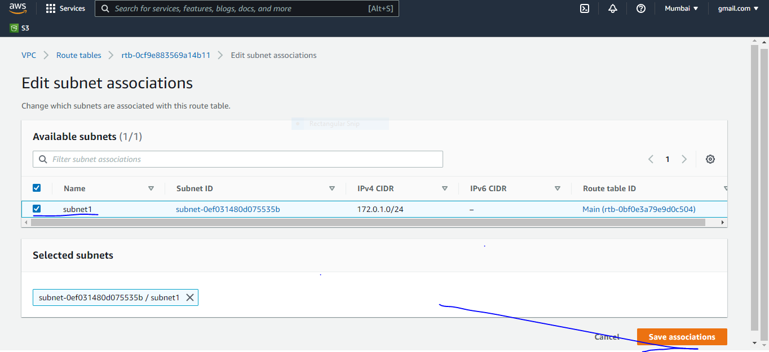

1. click your route table
2. Click route

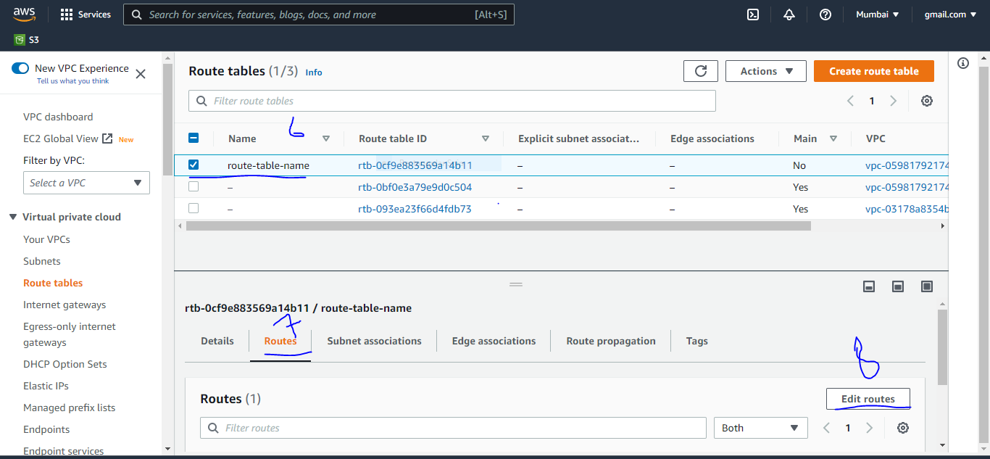

8.Click Edit route

9.Destination= 0.0.0.0/0

10.Internet gate ways id select

11.save

